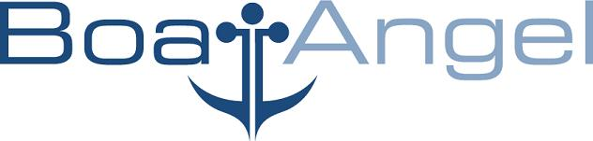Vancouver, B.C., V6J 4R3 Canada Tel: 604-654-2929 Fax: 604-654-1993

Dear Monica Selnar,

We produced an award winning Documentary DOPE. We are funding a Christmas album Northern Light Orchestra. I have enclosed a list of participating musicians, singers. We are possibly interested in Leigh Nash doing vocals on a track.

Thank you for considering this project.

Best

Brian Stewart

PS In the past I interviewed your artists BT and Andy Hunter for my show on DISH Rave America. We also licensed a track from your label for our compilation DVD RAVE AMERICA.

Boat Angel

Well, people we have that have actually lined up and/or played already includes:
Debbie Sledge -Sister Sledge (We are Family)
George Lynch - (Dokken, Lynch Mob)
Bruce Kulick - (Kiss, [Crazy Nights, Asylum, Exposed, Alive III, Revenge, Psycho Circus, Carnival of Souls] )
Jason Hook - (Alice Cooper)
Chuck Wright - (Quite Riot, Vanilla Fudge)
Lanny Cordola - (House of Lords, The Beach Boys)
Kip Winger - (Winger)
Ken Mary - (Alice Cooper, House of Lords)
Mark Slaughter - (Slaughter)
Robin McAuley - (Survivor)
Bill Leverty - (Firehouse)
David Ellefson - (Megadeth)

Other potentials at the moment incude:
Joe Lyn Turner - (Rainbow)
Bobby Kimball - (Toto)

